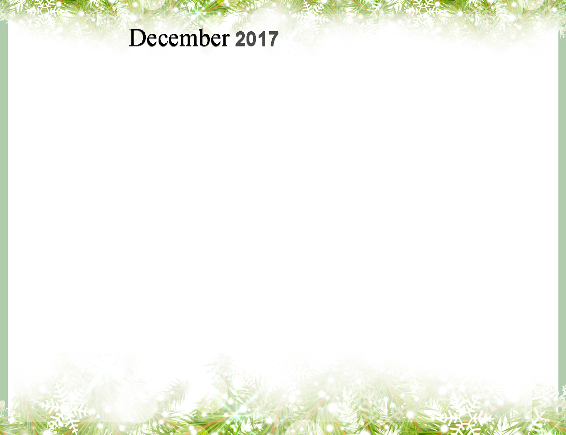
Sunday | Monday | Tuesday | Wednesday | Thursday | Friday | Saturday
 |  |  |  |  | 1 | 2
3 | 4 | 5 | 6 | 7 | 8 | 9
10 | 11 | 12  First Day of Hanukkah | 13 | 14 | 15 | 16
17 | 18 | 19 | 20 | 21  Winter Begins | 22 | 23
24 | 25  Christmas Day | 26  Kwanzaa Begins | 27 | 28 | 29 | 30
31

New Year’s Eve

Dec 1st |  |  |  |  | 10:45 Rozsa’s Exercise  2:00 Bible Study  3:00 Movie / Lounge | 10:00 Knit Wits  11:00 Tai Chi OW 2:00 p.m. Bridge  3:00 Movie / Lounge  3:30 Stick to the Rhythm with Rozsa-OW
3:00 Movie /  Lounge | 2:00 Balance Class  2:00 p.m. Bridge  3:00 Movie / Lounge  7 p.m. Euchre  3rd floor | 9:45 Chair Yoga  3:00 Movie /Lounge | 9:00 Billings Bridge  10:45 Rozsa’s Exercise  2:00 p.m. Bridge  3:15 Trivia with Sue | 11:00 Kars Luncheon  2:00 Balance Class  2:30 Art Group-4th floor | 9:00 Manotick shopping  10:45 Rozsa’s Exercise  2:00 Bible Study  3:00 Movie / Lounge | 10:00 Knit Wits  2:00 Open House Christmas Bingo  OW  2:00 p.m. Bridge  3:00 Movie / Lounge
3:00 Movie /  Lounge | 2:00 Balance Class  2:00 p.m. Bridge  3:00 Movie / Lounge  6:30 Christmas Songs and a Craft with Children ( Sparks)  Multipurpose room | 3:00 Movie /Lounge | 9:00 Kemptville Mall  10:45 Rozsa’s Exerc  2:00 p.m. Bridge  11:45 Xmas Party Brunch  1:30 Len Goldfarb sings  6-8 Renaissance Carolers OW | 1:15 EY Centre  Craft Show  2:00 Balance Class  2:30 Art Group-4th fl  6:30 Papa’s Friends  Barbershop meets Gospel Christmas | 9:00 Manotick shopping  10:45 Rozsa’s Exercise  2:00 Bible Study  3:00 Movie / Lounge | 10:00 Knit Wits  11:00 Tai Chi OVLC  2:00 p.m. Bridge  3:00 Movie / Lounge
3:00 Movie /  Lounge | 9:15 Shopping Barrhaven  2:00 Balance Class  2:00 p.m. Bridge  3:00 Movie / Lounge  7 p.m. Euchre 3rd fl | 9:45 Chair Yoga  3:00 Suites  Residents Council Meeting  3:00 Movie /Lounge | 10:45 Rozsa’sExercise  1:00 Pounds /Pulse/Pressure  2:00 p.m. Bridge  3:15 Trivia with Sue | 9:00 Shop at Carlingwood & Lunch  2:00 Balance Class  2:30 Art Group-4th floor  6:00 Local Christmas Light Tour | 9:00 Manotick shopping  10:45 Rozsa’s Exercise  2:00 Bible Study  3:00 Movie / Lounge | 10:00 Knit Wits  11:00 Tai Chi OVLC  2:00 p.m. Bridge  3:00 Movie / Lounge
3:00/Movie  Lounge | CHRISTMAS  DAY  2:00 p.m. Bridge  3:00 Movie /Lounge | BOXING DAY  3:00 Movie Lounge | 10:45 Rozsa’s Exercise  2:00 p.m. Bridge  3:15 Trivia with Sue | 2:00 Balance Class  2:30 Art Group-4th floor  5:00 Birthday Party with George on Piano | 9:00 Manotick shopping  10:45 Rozsa’s Exercise  2:00 Bible Study  3:00 Movie / Lounge | 9:15 Rideau Carleton. Slots  10:00 Knit Wits  11:00 Tai Chi OVLC  2:00 p.m. Bridge  3:00 Movie / Lounge  3:30 Stick to the Rhythm /OW
3:00 Movie /  Lounge  3-4:30 New Year’s Bash Peter Sinclair Trio O. W. | Garden View

